-- Skill demonstrated: 1 data screening
-- Question 1.1: How to have a viewing on all tables used in 'northwind.db' database?
-- Question 1.2: How to show all records of a certain table with its all attributes?
-- Question 1.3: How to show some records of a certain table?

-- Skill demonstrated: 2 data filtering
-- Question 2.1: How to filter out certain data out by 1/0,Yes/No,Notnull/Null characteristic?
-- Question 2.2: How to get only the desired limited lines of records?

-- Skill demonstrated: 3 data relationships
-- Question 3.1: When to use JOIN?
-- Question 3.2: When to use GROUP BY?
-- Question 3.3: When to use HAVING instead of WHERE?

-- Skill demonstrated: 4 Subqueires and UNION command
-- Question 4.1: How to use IN to organize subqueires?
-- Question 4.2: How to use UNION or UNION ALL?

- Skill demonstrated: 1 data screening
-- Question 1.1: How to have a viewing on all tables used in 'northwind.db' database?
SQL Queries
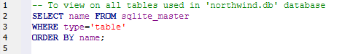
-- To view on all tables used in 'northwind.db' database
SELECT name FROM sqlite_master
WHERE type='table'
ORDER BY name;

Execution output:
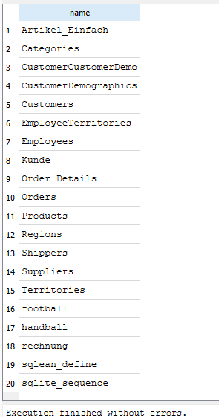

2
-- Question 1.2: How to show all records of a certain table with its all attributes?
SQL Queries
-- To show all records of table 'Categories' with all its attributes
SELECT * FROM Categories;
Execution output:
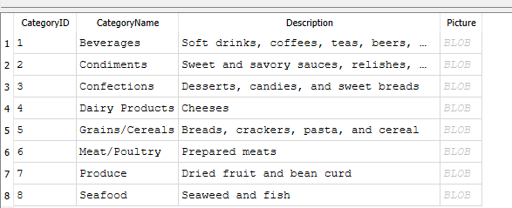

2
Question 1.3: How to show some records of a certain table?
SQL Queries
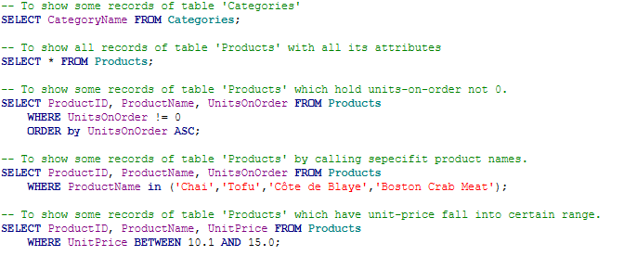
-- To show some records of table 'Categories'
SELECT CategoryName FROM Categories;

-- To show all records of table 'Products' with all its attributes
SELECT * FROM Products;

-- To show some records of table 'Products' which hold units-on-order not 0.
SELECT ProductID, ProductName, UnitsOnOrder FROM Products
WHERE UnitsOnOrder != 0
ORDER by UnitsOnOrder ASC;

-- To show some records of table 'Products' by calling sepecifit product names.
SELECT ProductID, ProductName, UnitsOnOrder FROM Products
WHERE ProductName in ('Chai','Tofu','Côte de Blaye','Boston Crab Meat');

-- To show some records of table 'Products' which have unit-price fall into certain range.
SELECT ProductID, ProductName, UnitPrice FROM Products
WHERE UnitPrice BETWEEN 10.1 AND 15.0;

Execution output:
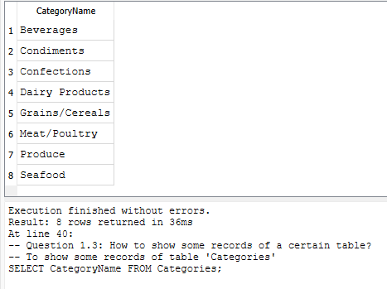
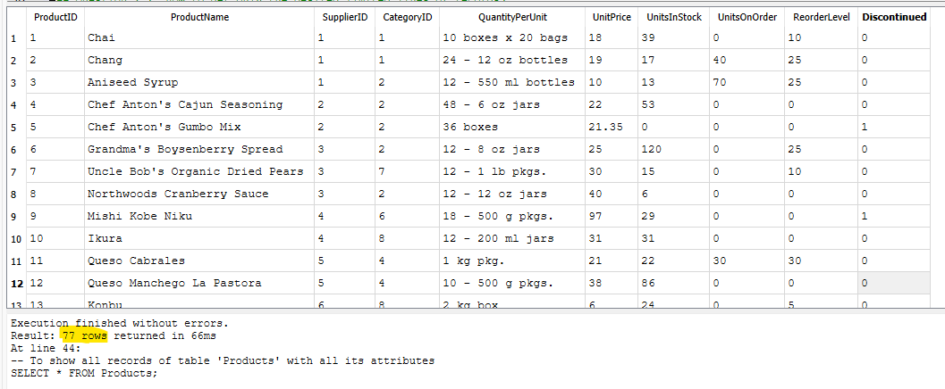
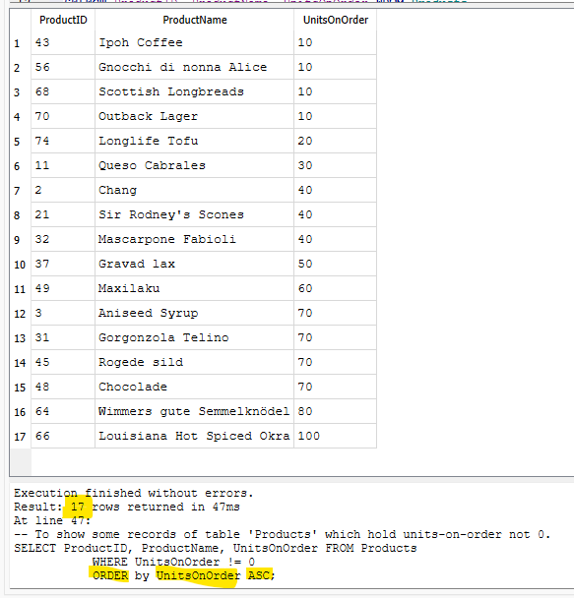
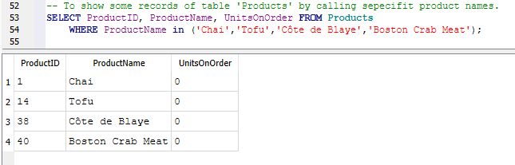
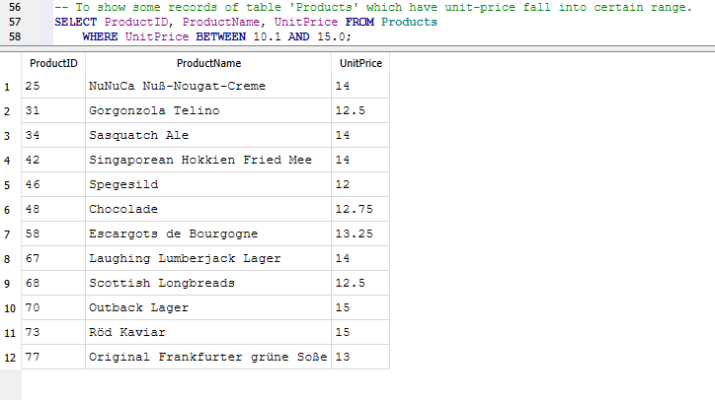

- Skill demonstrated: 2 data filtering
-- Question 2.1: How to filter out certain data out by 1/0,Yes/No,Notnull/Null characteristic?
SQL Queries
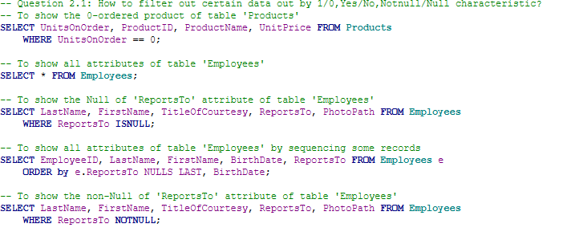
-- To show the 0-ordered product of table 'Products'
SELECT UnitsOnOrder, ProductID, ProductName, UnitPrice FROM Products
WHERE UnitsOnOrder == 0;

-- To show all attributes of table 'Employees'
SELECT * FROM Employees;

-- To show the Null of 'ReportsTo' attribute of table 'Employees'
SELECT LastName, FirstName, TitleOfCourtesy, ReportsTo, PhotoPath FROM Employees
WHERE ReportsTo ISNULL;

-- To show all attributes of table 'Employees' by sequencing some records
SELECT EmployeeID, LastName, FirstName, BirthDate, ReportsTo FROM Employees e
ORDER by e.ReportsTo NULLS LAST, BirthDate;

-- To show the non-Null of 'ReportsTo' attribute of table 'Employees'
SELECT LastName, FirstName, TitleOfCourtesy, ReportsTo, PhotoPath FROM Employees
WHERE ReportsTo NOTNULL;

Execution output:
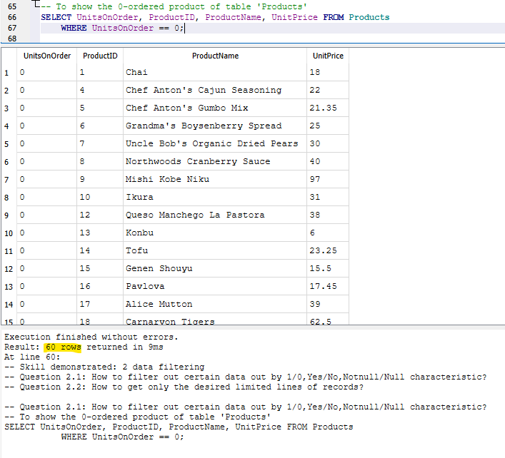
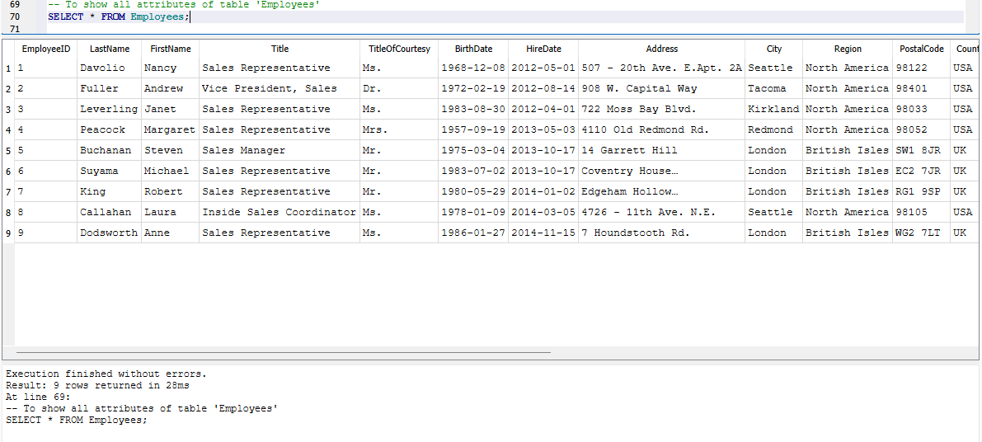
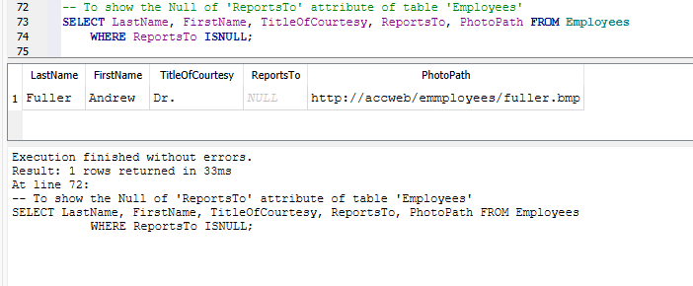
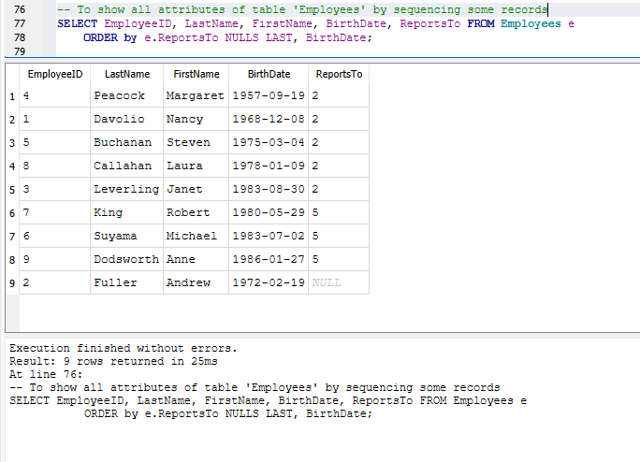
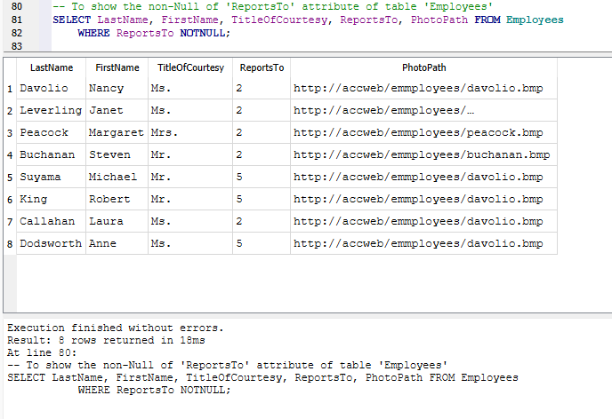

2
-- Question 2.2: How to get only the desired limited lines of records?
SQL Queries
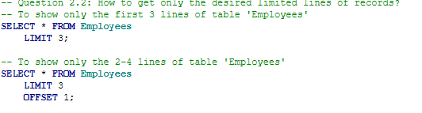
-- To show only the first 3 lines of table 'Employees'
SELECT * FROM Employees
LIMIT 3;

-- To show only the 2-4 lines of table 'Employees'
SELECT * FROM Employees
LIMIT 3
OFFSET 1;
Execution output:
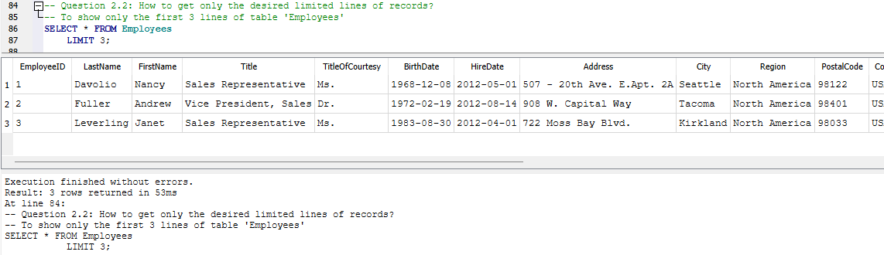
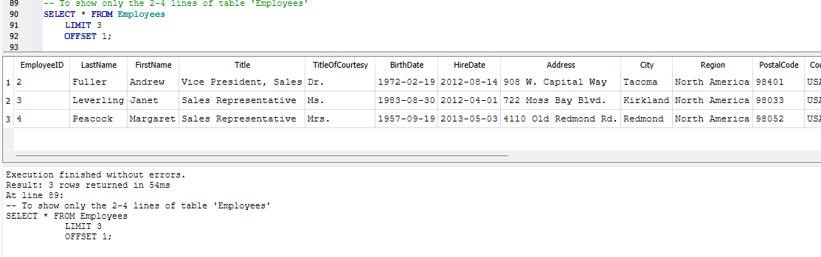

- Skill demonstrated: 3 data relationships
-- Question 3.1: When to use JOIN?
-- Question 3.2: When to use GROUP BY?
-- Question 3.3: When to use HAVING instead of WHERE?

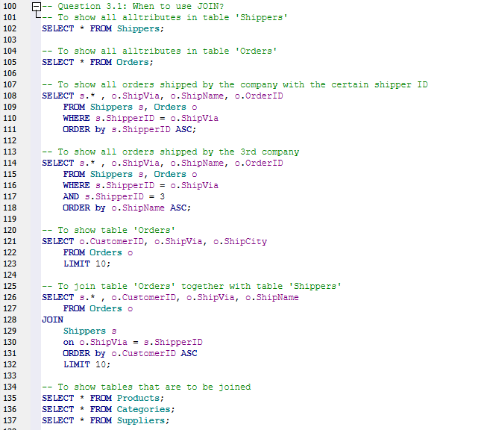
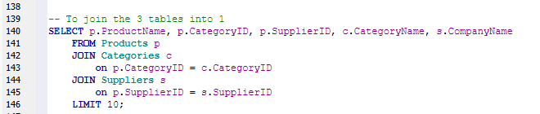
-- To show all alltributes in table 'Shippers'
SELECT * FROM Shippers;

-- To show all alltributes in table 'Orders'
SELECT * FROM Orders;

-- To show all orders shipped by the company with the certain shipper ID
SELECT s.* , o.ShipVia, o.ShipName, o.OrderID
FROM Shippers s, Orders o
WHERE s.ShipperID = o.ShipVia
ORDER by s.ShipperID ASC;

-- To show all orders shipped by the 3rd company
SELECT s.* , o.ShipVia, o.ShipName, o.OrderID
FROM Shippers s, Orders o
WHERE s.ShipperID = o.ShipVia
AND s.ShipperID = 3
ORDER by o.ShipName ASC;

-- To show table 'Orders'
SELECT o.CustomerID, o.ShipVia, o.ShipCity
FROM Orders o
LIMIT 10;

-- To join table 'Orders' together with table 'Shippers'
SELECT s.* , o.CustomerID, o.ShipVia, o.ShipName
FROM Orders o
JOIN
Shippers s
on o.ShipVia = s.ShipperID
ORDER by o.CustomerID ASC
LIMIT 10;

-- To show tables that are to be joined
SELECT * FROM Products;
SELECT * FROM Categories;
SELECT * FROM Suppliers;

-- To join the 3 tables into 1
SELECT p.ProductName, p.CategoryID, p.SupplierID, c.CategoryName, s.CompanyName
FROM Products p
JOIN Categories c
on p.CategoryID = c.CategoryID
JOIN Suppliers s
on p.SupplierID = s.SupplierID
LIMIT 10;
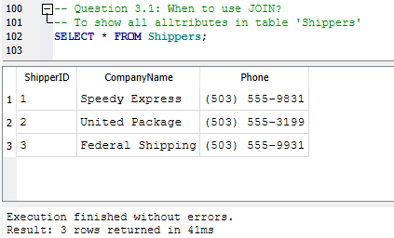
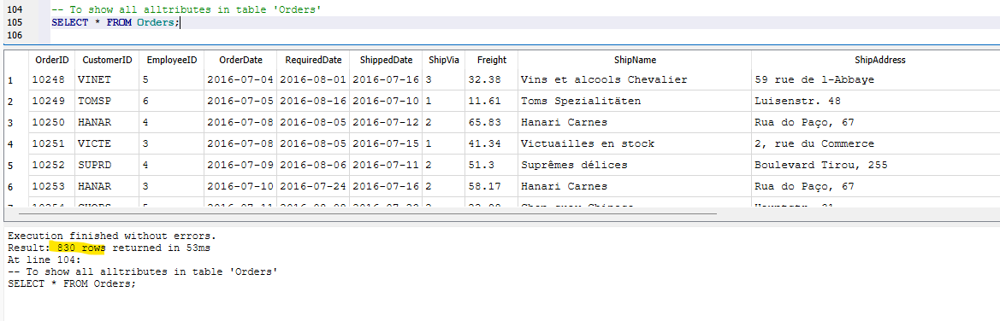
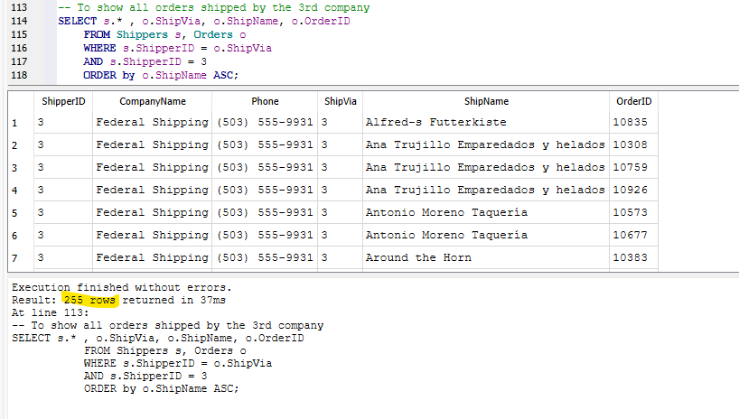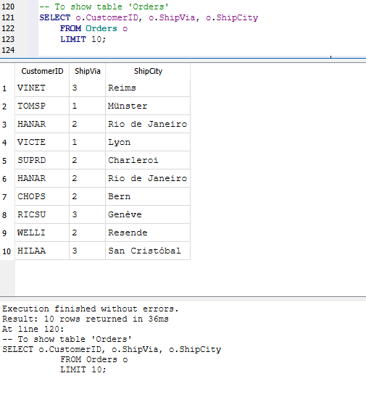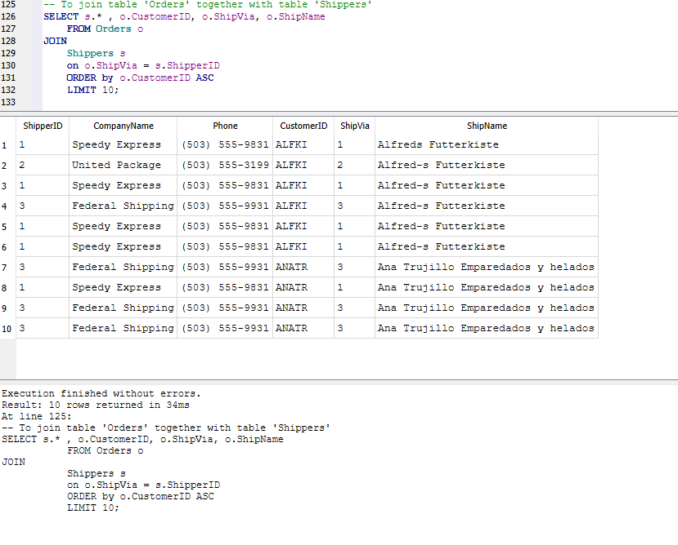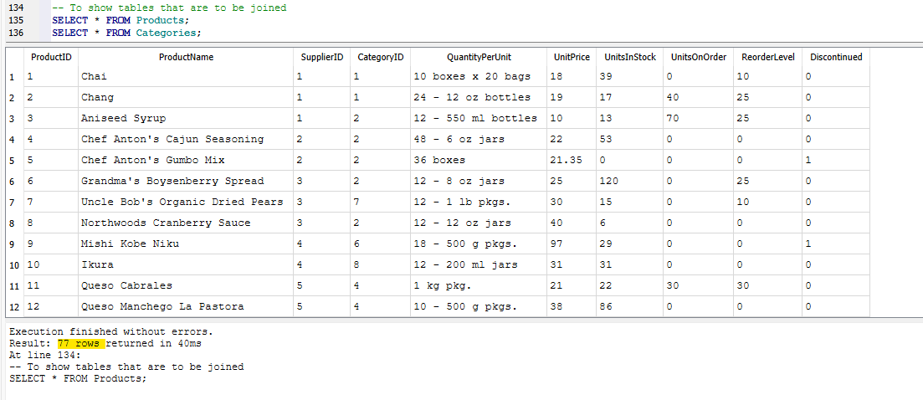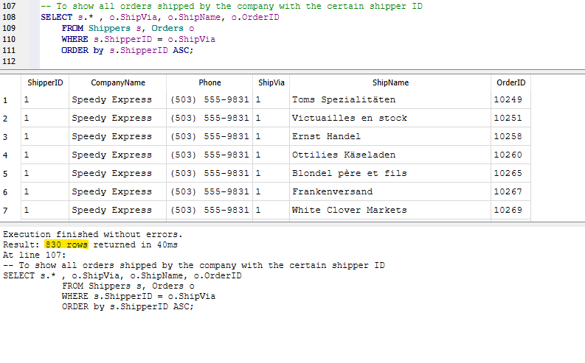
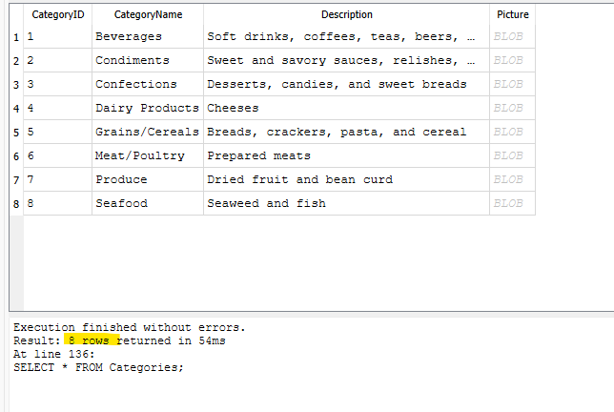
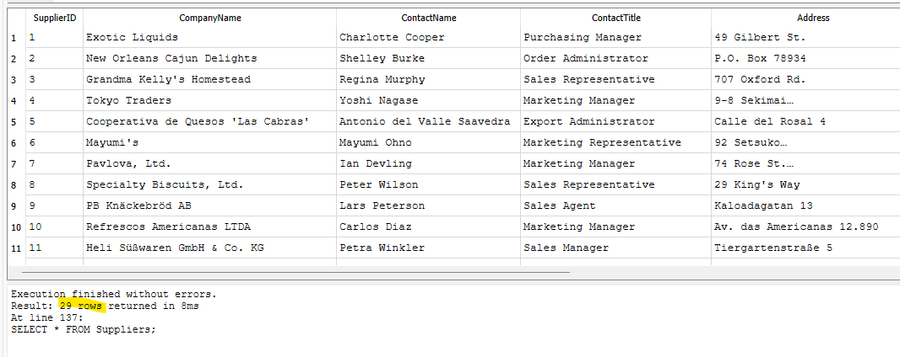
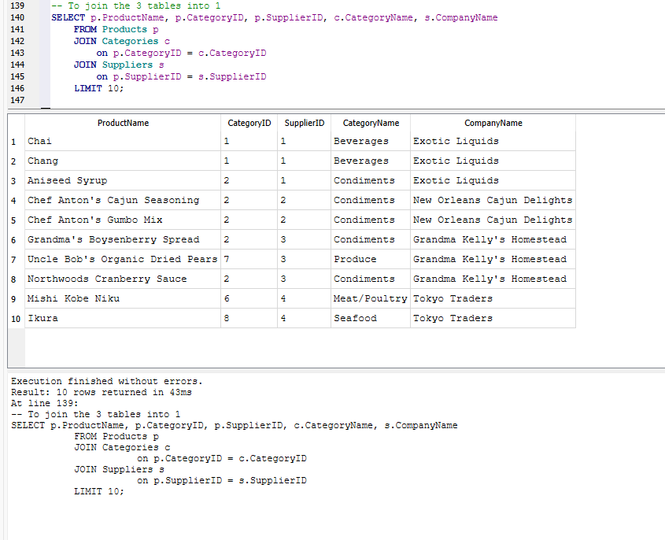
-- Question 3.2: When to use GROUP BY?

- Skill demonstrated: 4

